WMEC111 Introduction to Video Games

Effects used in this assignment

Terrain 25%

Appropriate 25%

First-person controller

Textures with normal maps 10%

Animation： light and door 10%

Light: directional light and fire 5%

Particle effects: fire 10%

NavMesh Agent: enemies 5%

I follow my game documents, My Unity Game has two main areas: an outdoor section and an indoor section.

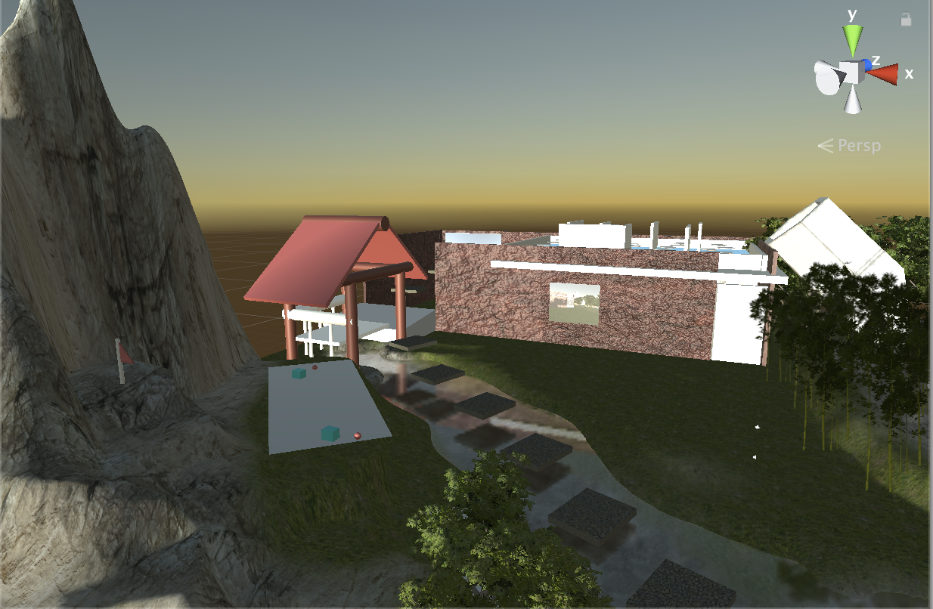

About outdoor section. The game has a vast terrain, and I use "Terrain Assets" to draw up the ground. I built some mountains and trenches and added some trees and grass. I also give these objects some specific textures.

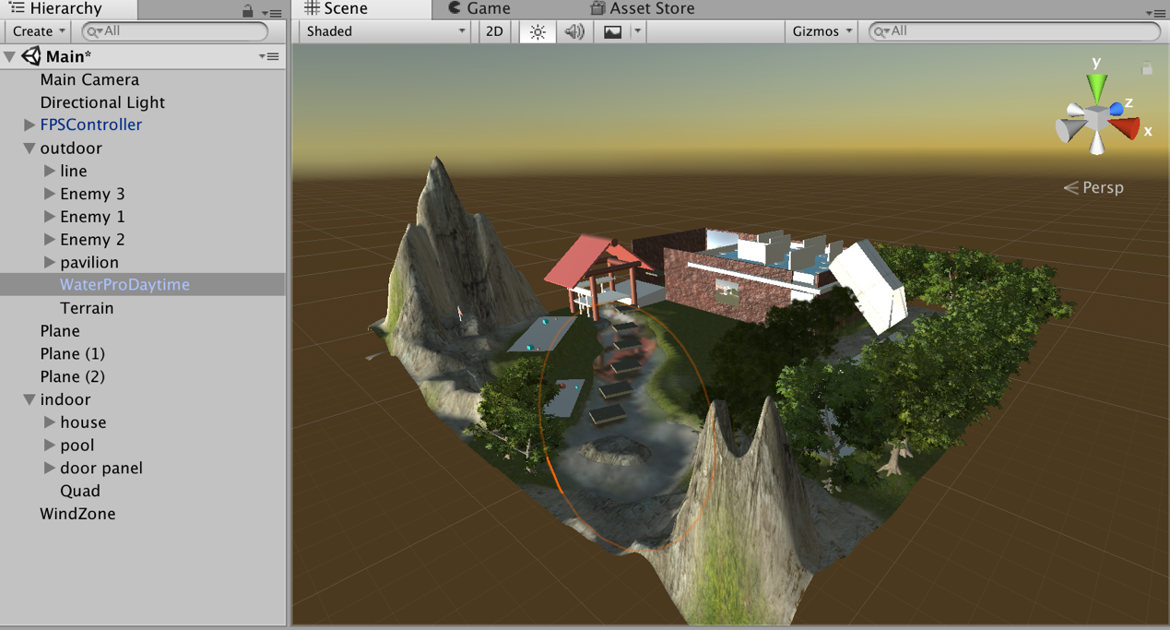

Then I have a directional light with an "Animation" to simulate sunrise and sunset and added wind zone and a river in the origin document.

And I used "3D object" to create a pavilion with some textures and to build a particular path on the river to make players can follow my routes.

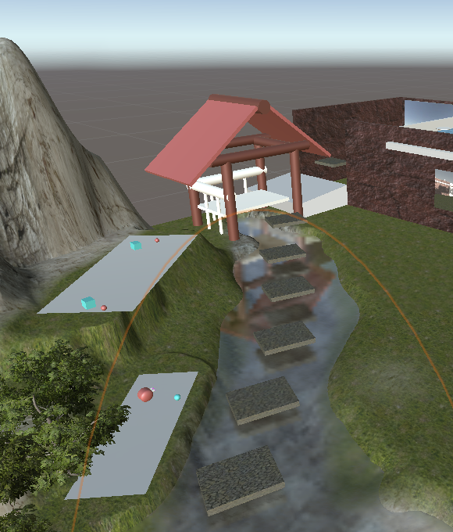

In the terrain, I used the NavMesh Agents to build three groups of enemies to patrol and chase.

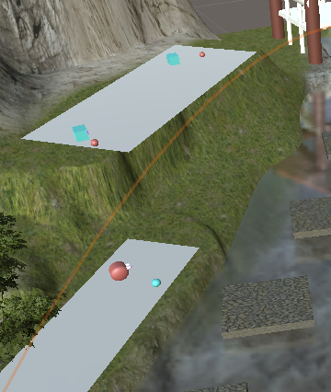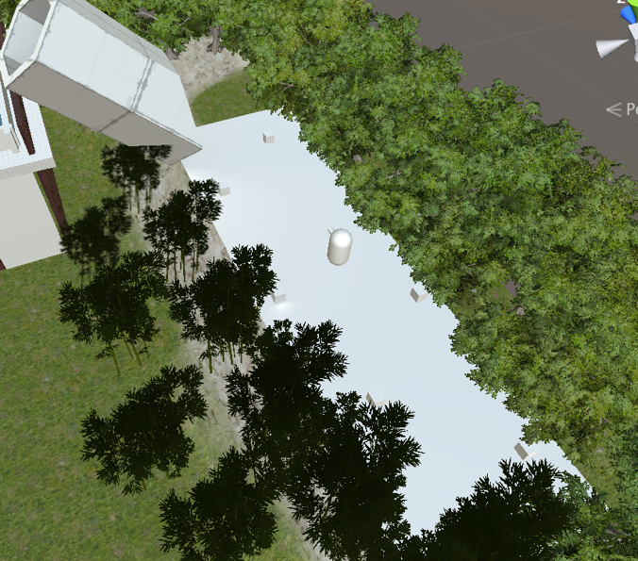

About indoor section, there is a new idea for Game Documents, I used "3D Object" and Probuilder to add a house with a swimming pool and a small labyrinth to make player to explore.

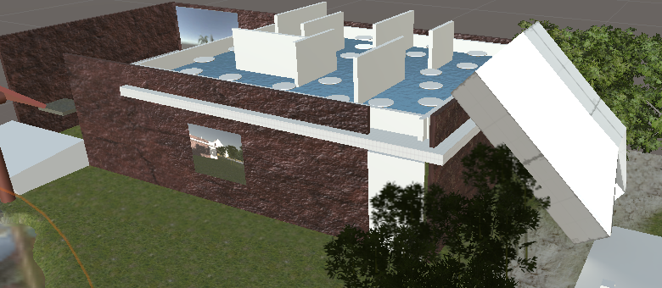

And this house added a door with triggering animations.

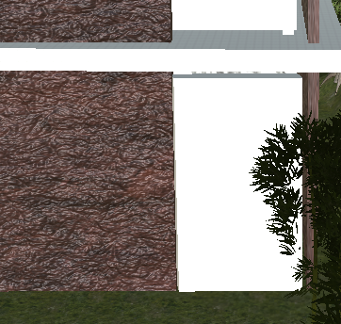

Then I changed the light to used emissive materials to make four torches to make indoor brighter.

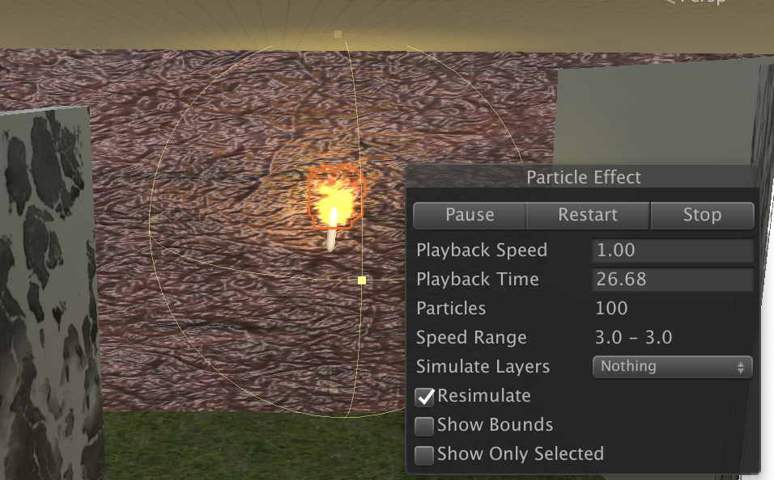

This is a new one. The house added a normal picture in the indoor section. I used a quad to create a TV screen to render the player's view on the outside wall of the house by a camera.

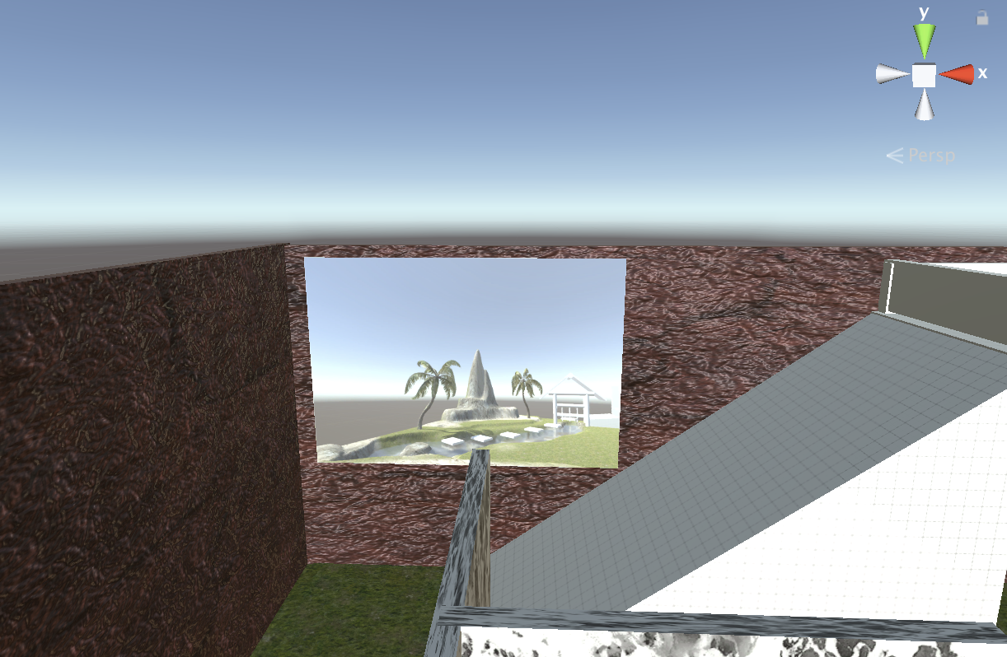

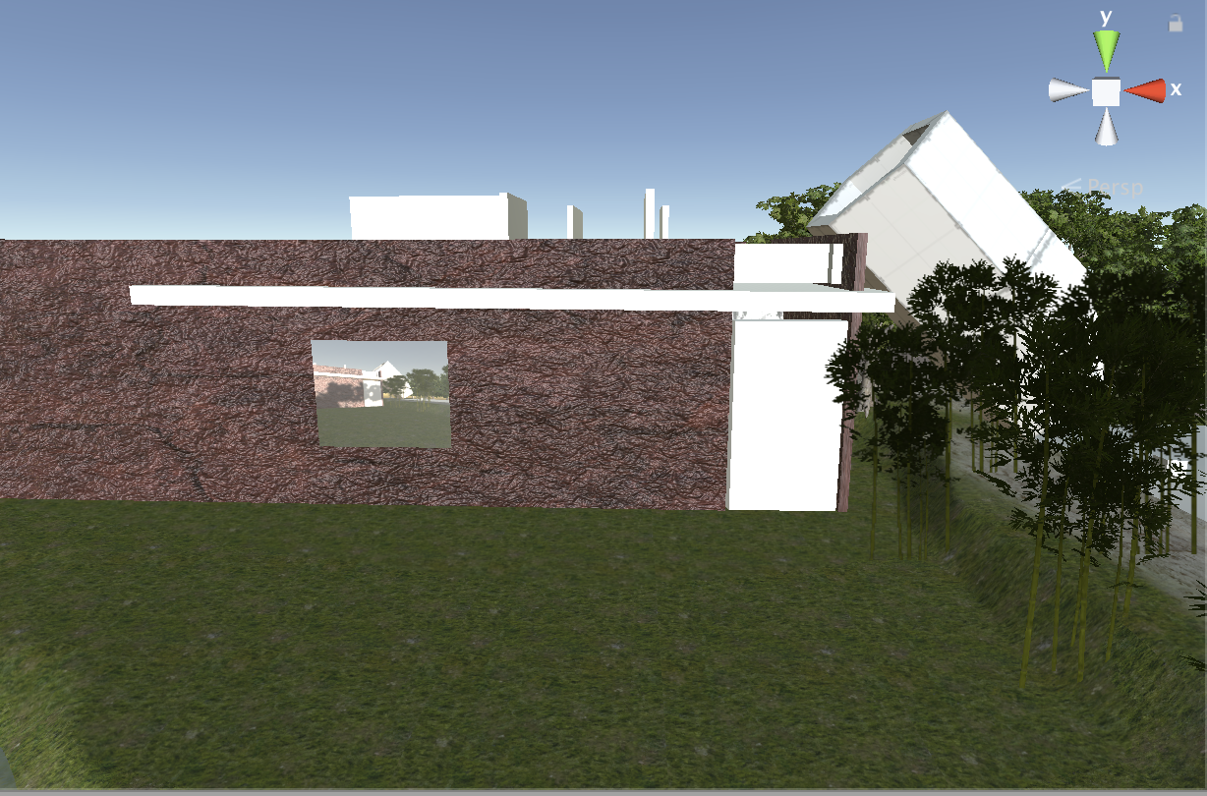

And I added other cameras such as FPSController and the main camera. Finally, I added post-processing effects to apply other effects.